Science
Aristotle have investigated the science of cosmetics. They have tested different shampoos to see which lathered the most. They have used measuring apparatus accurately to make soaps. Students particularly enjoyed testing different bath bombs and comparing the volume of gas produced. We are now looking at substances on a particle scale.
Socrates have been looking at animal and plant cells and gained knowledge on the organisation of systems in the human body. They looked at the digestive system and modelled how food travels from mouth to toilet. Students are excited to try a lung dissection this week.

Maths
In Maths, Aristotle have gained confidence in writing and using large numbers and decimals. They have learned how to use rounding to make estimations and check answers. More recently students have progressed to using multiplication facts to solve division problems.
Socrates have been working on place value, addition and subtraction. Students have been using the column method to add and subtract and cemented their skills by solving word problems. Students have also been using their skills in real life problems involving money and measurements. We have also touched upon measurement of time, discussing days, weeks and months. Students have been looking at calendars and answering questions. Next half term we will be moving on to multiplication and division.

Uniform
Following Market Research with the students we are changing our school uniform to include T Shirts and Sweatshirts/Hoodies rather than polo shirts and fleeces. Please fill in the table below and return to school as soon as possible to ensure the correct sizes are ordered for your child. The first T shirt and Hoodie/Sweatshirt will be provided by school and any following orders are priced at £8.00 per T Shirt and £12.00 per sweatshirt/hoodie.
Your child can have their initials on their items if you wish.
Extra Curricular Lunchtime Clubs
Mondays: Film Club/Lego Club
Tuesday: Baking Club/Chilling Club
Wednesdays: Walking Club/Art Club
Thursdays: Board and Card Game Club/Chilling and Reading Club
Fridays: Art Club/Chilling Club

Visual Arts
We explored photography as part of the Virtual Art module. Photography is a creative way of capturing a moment in time, mood or opinion. During this module we identified a subject area, we
explored the use of cameras, looking at rule of thirds, and different angle shots. After a brief was developed students discussed composition, and how they would like their final photographs to look.
On Thursday 13th October all students went to Longton part to take photographs, Socrates brief was ‘Autumn Days’ and Aristotle’s brief was to capture a ‘Traditional features of the park’.
After the October break visual arts will then focus on the 7 elements of art, colour, form, line, shape, tone, texture, and pattern.

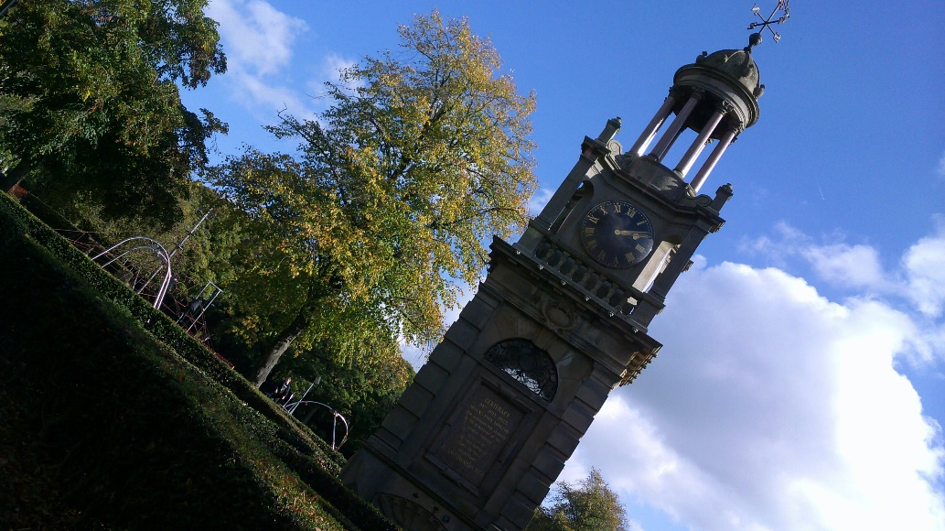
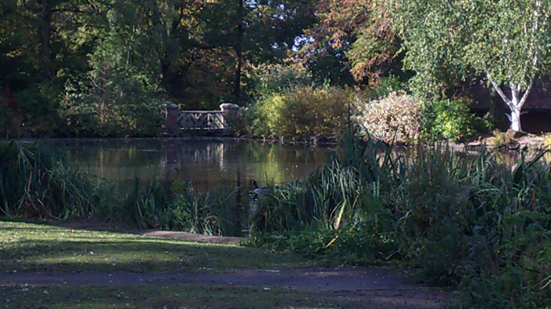
ICT
Socrates:
This half term we have been thinking all about online safety. Students have been learning about what a digital footprint is and why it’s important to really think about what we might share online. Students have also been thinking about cyberbullying and what to do if it is happening to themselves or somebody around them. We have also, been looking at websites and how to tell if they are safe and secure and suitable for their age.
Aristotle:
Students have made a great start on their portfolio for the IT skills award. Students have been thinking about computer security and why it’s important. Students have been researching different software that are available to keep computers safe and secure. Students have been thinking carefully about online transactions and why we need to ensure information that we input is secure. After half term students will complete this unit and move on to online IT systems.

PE:
This half term we have been to the YMCA and learned the skills needed to play dodgeball. Students also chose to have a go on roller skates and play basketball. After half term we will start attending the gym, where students will be able to use the cardio equipment. We will also be working on hand eye coordination as we play badminton/tennis.

Cooking
The kitchen this term has been extremely busy with lots of cooking and, of course, tasting.
We have celebrated British Food Week looking at what we mean by British food. We have also discussed why it is important to eat British food. Some of the dishes made were – Toad in the hole, Roast dinners, Victoria sponge. We hope some of our families enjoyed these dishes too. We have also looked at risks in a kitchen and important hygiene techniques.

Intuition School are now providing an outreach service which enables a specialist teacher to visit children with complex needs, in their own homes, to provide a tailor-made curriculum to meet their individual needs. They have the opportunities to achieve their educational goals and acquire the skills they need to gain independence in learning and in life. Outreach also works very closely with parents/carers to provide them with support, training and advice. The outreach service is led by Karen, a specialist teacher with 15 years of experience working with children with a range of special educational needs and has furthered her knowledge with various studies including gaining a post graduate certificate in language and communication impairment in children. The children and their families also work closely with Sue, our wellbeing coach, who also visits the family weekly. We currently have two KS3 children, supported by the outreach service. These are seen each day by Karen and/or Sue.

Vacancy:
As our school continues to grow we have the opportunity for a parent Governor. Our school Governors play an important part in improving the education journey and lives of our students. Our Governors are from a variety of backgrounds. The parent governor will work closely with us to advocate for parents and to share information, guidance and challenge. This is a voluntary position and requires between 4-6 meetings/visits a year.... please email a letter of interest to emma@diamond-families.org.uk or call 01782315758 by 25th October
Health and Wellbeing
Students are working towards the AIM level 1 award in Health and Wellbeing. This term we have been looking at Understanding feelings and emotions. We have looked at what emotions and feelings what they mean and learning strategies to manage emotions whether they are positive or negative. Next term we will continue this topic.
Upcoming Dates for your diary:
Autumn Term 1 ends; 21st October 2022
Autumn Term 2 begins: 31st October 2022
Autumn Term 2 ends: 16th December 2022
Spring Term 1 begins for staff: 3rd January 2023
Spring Term 1 begins for students 5th January
Christmas Lunch Date: 8th December 2022
Pantomime Trip: 13th December 2022
Christmas celebration for parents: 14th December 2022

Anti-bullying week – Odd Socks Day 14th – 18th November
PSHE / RSE
This term in PSHE we have been looking at what is unique? What makes the students unique learners.
The students completed questionnaires to work out what learners they were either visual, auditory or kinesthetic.
We have remembered and reflected on our Queen’s life. The students wrote quotes about the Queen which were extremely respectful and thoughtful.
We have also looked and reflected on important days around PSHE mental health day, World Values Day.
Our students have been involved in lots of discussions and debates on these sensitive topics and have shown maturity throughout the lessons.
In RSE we have been looking at the roles and responsibilities within a family – we will continue to look at this topic next term.
English
Aristotle have started the theme Titanic Times looking at non-fiction texts to establish what life was like just before World War One. We focused on Stoke on Trent but also on international events, including the sailing and sinking of the Titanic. We visited The Regent Theatre to see An Inspector Calls, which focuses on Class, Wealth, Gender, Responsibility and Society. Aristotle have produced some pieces of writing comparing and contrasting the times, proving points about characters and we are now working on analyzing the play.

Parent events
We are running two events for our parents/carers:
The Parent Support Group is on Mondays at the
Treehouse Centre, Bentilee from 10.00 until 12.00.
This group is free for parents of Intuition School’s students.
It is friendly supportive small group helping to solve any issues and improve relationships within the family.

The Online Parent Workshop runs from 9.45 until 10.45.
It is a free workshop providing guidance and information on many areas including budgeting, health, local events, school attendance.

Please contact sue@diamond-families.org.uk or 07305673869

Student’s Name _____________________________

-------------------------------------------------------------
T Shirt | How many? | Sweatshirt | How many? | Hoodie | How many?
Small |  | Small |  | Small
Medium |  | Medium |  | Medium
Large |  | Large |  | Large
X Large |  | X Large |  | X Large

Safeguarding & attendance if you are worried about a child within our school community please contact Rebecca on 01782315758

As stated within the WORKING TOGETHER TO IMPROVE SCHOOL ATTENDANCE SEPTEMBER 2022
’Pupils with the highest attainment at the end of key stage 2 and key stage 4 have higher rates of attendance of the key stage compared to those with the lowest attainment’

Health and safety - Please note that our site is a regulated site and all visitors (except for parents) MUST have a pre-arranged appointment

Our school is a non-vaping and non-smoking site - please respect our policy

