July 2022  Maths  During the Summer term we have continued to work on our real-life skills. We have been solving problems involving money. We have also been understanding properties of shape, finding lines of symmetry and spotting shapes in the environment.  English  This term we have been learning all about the Windrush generation. We have been reading the book ‘Windrush child’ by Benjamin Zephaniah.  We have been thinking about Leonard’s life in Jamaica and comparing it to his life in England.  We have also been discussing the key themes that run throughout the book. |  |  | Science  As the Sun has started to shine, we have made the most of it in Science by taking a look at plant reproduction. Students have dissected flowers and used a digital microscope to visualize pollen grains. We have investigated the conditions needed for plant growth using cress seeds. Cabomba pond weed allowed us to see photosynthesis in action and we could count the bubbles of oxygen produced. We’ve looked at pollination and why bees and butterflies are so important. Students have collected materials for and constructed an insect hotel in the Intuition garden. Next we plan to launch our homemade seed bombs in the local area to support those important pollinator insects.  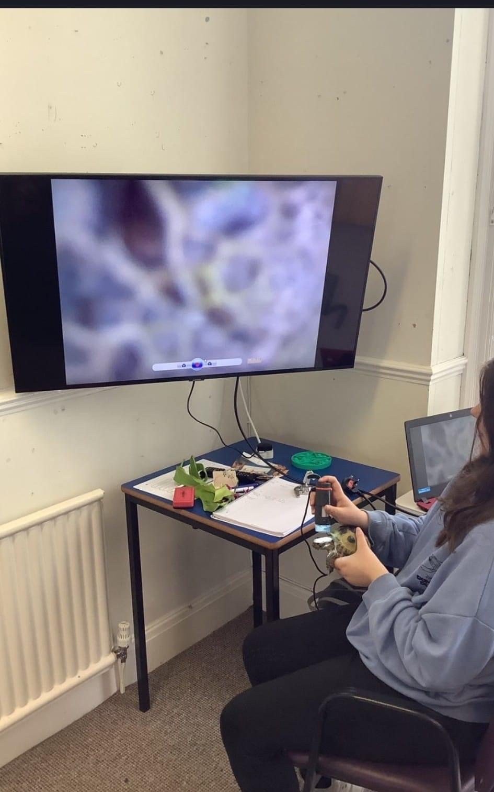

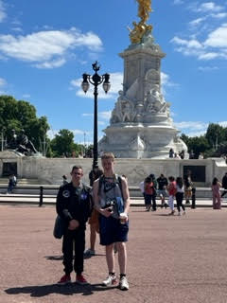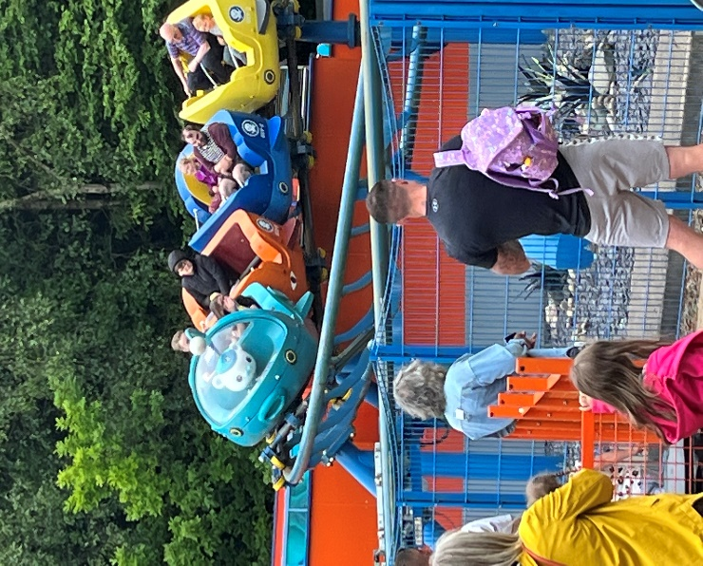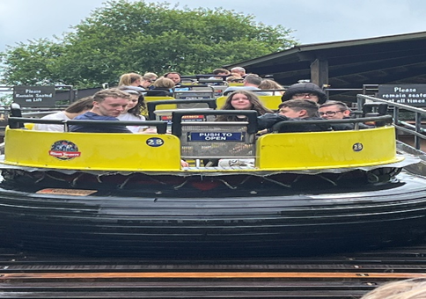
School trips / reward days
This term has been a very busy one where the students have visited numerous places.
Year 11 went on there end of term trip to London! What an amazing adventure we had visiting all the sites. Then on the Friday the students went to Alton Towers for a fun filled day out … everyone needed an early night after all the walking we did.

Personal Wellbeing / PSHE

The first half of this term we looked at everything Royal and celebrated the Queen’s jubilee in style with our Jubilee afternoon tea celebration where the students made all the food then we afternoon of entertainment bingo, singing and even a royal visit from her majesty.

This half term we took part in various activities which looked at LGBT month we also celebrated RSE day and neurodiversity month. Where we did fact files on celebrities with neurodiversity. The students have taken a really mature approach to PSHE this year school year where we have looked at extremely sensitive topics such as stereotyping, bullying, extremism and relationships.

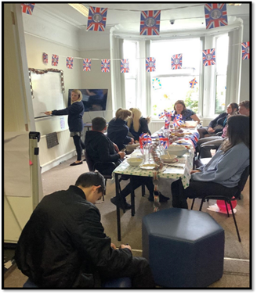

#  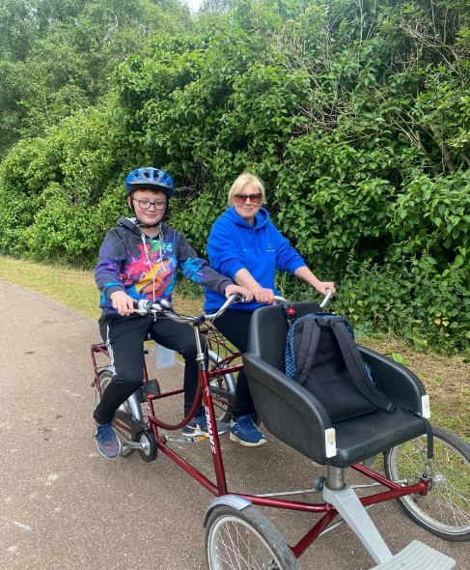  Message from the Principal:  Thank you so much for a fantastic first year at Intuition School – What a journey!  All of the students have achieved fantastic results. I am super proud of the Year 11 students and their resilience over the last year. Year 2 for me is going to be even better – I have so many more exciting things planned for us.  I am so impressed with our new starters too – it feels like they have always been with us as they fit in so well!  from Anna:  I would like to say a huge thank you to the Intuition Team  Special thanks to:  Clare: for excellent trip and event coordination  Amy: for excellent cross curricular planning links  Nicola: for making Science fun and interactive  Sophie: for keeping the boat steady and on course!  Sam: for being amazingly adaptable, trustworthy and reliable  Sue: for her unbelievable ability to empathise with and engage our parents and carers  Emma: for her advice and support  We will be welcoming Rebecca and Karen to our team from September 2022 |  |  | 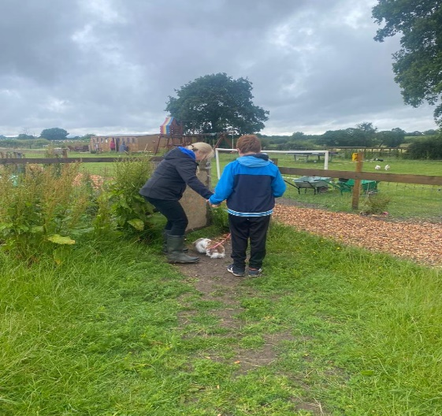  From September 2022 there are regular Attendance and Engagement Reward Trips planned for the students who are attending consistently and trying their best when they are in school. This includes Ninja Warrior, Go-Karting and Christmas treats.  Outreach sessions  This summer term has been a busy one with students accessing our outreach programme – which has involved visiting places such as:  Rudyard lake  Green door cycling  Dog walking  Brick cafe  Horse riding  Walking  Brough Park  Sue and Alex have also been researching ducks and their eggs. At intuition we have eggs in an incubator we can’t wait to see in the holidays how many will hatch …  Our students spoke so we listened:  Watch out for changes to our school uniform and individualised treats/trips for the students who wear the uniform the most – the higher the percentage of attendance in uniform - the higher the chance of an individualised treat/trip.
Important Dates:

Term ends for Summer: Wednesday 20th July 2022
Autumn term begins for students: Wednesday 7th September 2022
Theatre trip – “An Inspector Calls” at The Regent Theatre – Wednesday 5th October 2022 / Thursday 6th October 2022 {Date TBC}

Childhood education is a precious time that should be fun and nurturing. It is our mission to empower and inspire learners to enjoy education and seek their own true potential”
www.intuitionschool.co.uk 01782315758

 | Website: |  |  |  | Contact: |  |  |  | Email:

