Useful safeguarding information and contact numbers for parents/ carers and students

Useful Numbers below..
Samaritans - 116 123
Childline - 0800 1111
NSPCC - 0808 800 5000
Mind - 0300 123 3393

Tips for online safety
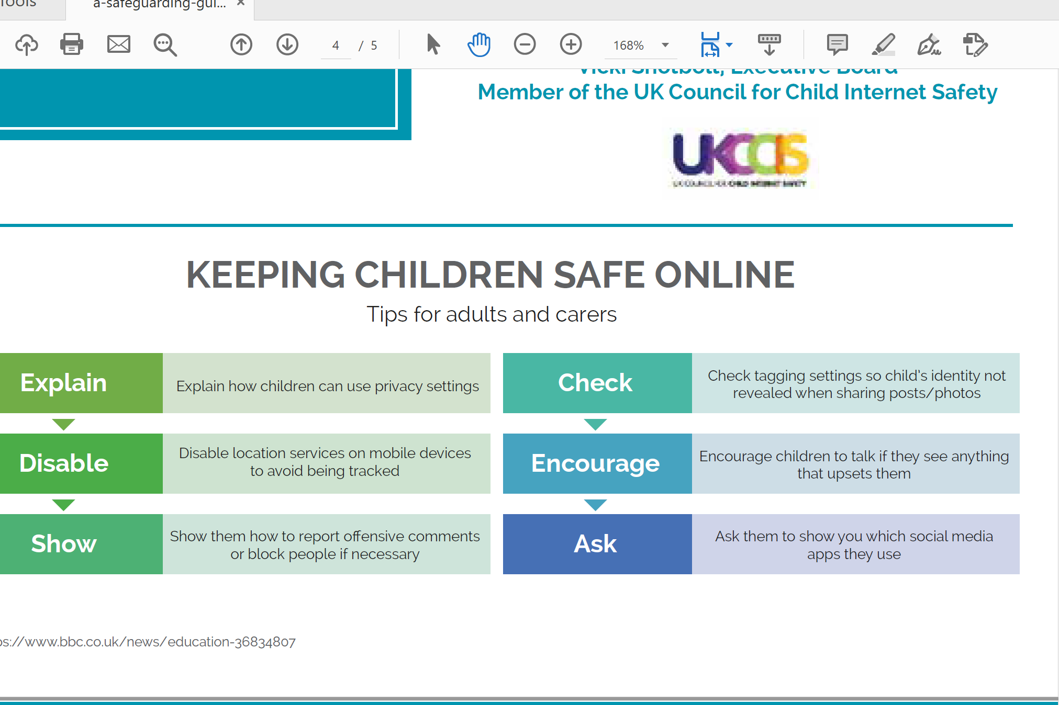

"Getting switched on to online dangers" click on this link to view the Safeguarding Children Board publication re. on online dangers.
The internet is a wonderful tool, offering unprecedented opportunities for communication, information, education and experiences from across the world. What’s more, we can access the internet whenever and wherever we choose, whether from a personal computer, laptop, mobile phone or games console.
Alongside these many positive benefits, however, there are risks which can reflect those in the off-line world. There are people who will use the internet to gain access to children and young people with the intention to harm them. It is vitally important, therefore, just as you would protect your child in the real world, you also protect them when they are online.

Online grooming
Adults who want to look at inappropriate images of children and young people, engage children and young people in sexual acts, or talk to them for their own sexual gratification are called child sex abusers.
Child sex abusers will use the internet to anonymously make contact with children and young people, often using a variety of grooming techniques to do so. They will build trust with children and young people by lying to them and often pretending to be someone that they are not. For example, they will pose as someone much younger than they are, or set up a persona to mask their true identity, and to build up friendships with children and young people.
After a while, they will attempt to engage the child or young person using more intimate forms of communication, for example with the use of images and webcams. Child sex abusers will often use blackmail and guilt as a way of getting a child or young person to meet with them.

Social networking
Chatting with friends online can be great fun, but sometimes children and young people may find themselves in situations where they feel uncomfortable or out of their depth. Children and young people will often share friends, assuming that because someone is a friend or relative of someone they know, they must be trustworthy. But every time a child or young person give out their personal details to strangers, they are putting themselves at risk.
The online world can seem different to real life, and children and young people can sometimes say and do things that they wouldn't normally do if they met someone face to face. This can include giving out personal information such as mobile numbers and pictures of themselves.

Mobile phones
Many new mobile phones have web access, which means that young people can access the internet wherever they are, and without any supervision. Picture and video messaging are also common features on mobile phones, making it easy for inappropriate images to be shared around several phones, edited and even put online.
Young people should be aware that they put themselves at risk of mobile bullying, or inappropriate intimate contact if they give out their mobile number to people they know or don't fully trust.

Terrorism and violent extremism
People involved in terrorism and violent extremism will exploit the internet for both operational purposes and as a tool for radicalisation and recruitment. This represents a serious risk to vulnerable individuals using the internet.
So how can you protect your child online?
- Don’t put a computer in your child’s bedroom – it is better located in a communal area where you have sight of it.
- Ensure your child knows that they shouldn’t give out personal information over the internet.
- Ensure your child knows that they should never go to meet anyone that they have met over the internet.
- Know what sites your child accesses and the people that they talk to.
- Stay alert to any sudden mood changes or major changes in habits, particularly in increased secretiveness.
Sextortion - CEOP link to advice for parents and individuals and sextortion.

Zipit do?
If someone’s tries to send naked images youngsters can use the images on Zipit to keep the situation in control. Zipit helps to get flirty chat back on the right track. It's packed with killer comebacks and top tips to help teenagers stay in control of the chat game.
Users can:-
- Save images onto their device and share them with friends.
- Share images on Facebook, Twitter, BBM or via email.
- Find out how to deal with a sexting crisis.
- Get advice on how to flirt without failing.
- Call ChildLine or save the number to a mobile phone.
Images can also be shared from Zipit through other apps like Whatsapp or Instagram, depending on the type of phone and what apps are downloaded.
Zipit is free to download, but if images are sent as a text with a picture (through MMS or Multimedia Message Service) there will be a charge by your mobile provider.

Top Tips for on line safety are attached below
- Cyber bullying
- On line Grooming
- Facebook
Useful links
- www.nspcc.org.uk,
- www.barnardos.org.uk
- netmums
Staffordshire police advice
- snapchat safety
- minecraft safety
- xbox one safety
- playssation 4 safety
www.thinkuknow.co.uk: the main UK Government website with advice for parents on how to keep children safe online
Child Exploitation and Online Protection Centre (CEOP) is the Government body dedicated to eradicating abuse of children. Concerns about inappropriate contacts between a child and an adult, including online, can be reported directly to CEOP.
The Internet Watch Foundation (IWF) works to remove illegal material from the internet. If you have found any material you believe to be illegal e.g. child sex abuse images, other obscene material or material which incites racial hatred, you can report it to the IWF

See below some useful information / posters for contact details etc
