Important Dates:  Staff Training: 1st and 2nd November  Term begins for students on 3rd November  Half Term Focus  This Half Term we have introduced our brand new uniform, which is really smart, as you can see from the photos. It incorporates a navy polo shirt and fleece. The first set will be provided to your young person free of charge and, if they do not already have one at home, they will bring it home on Wednesday 15th December 2021.  From January 5th it is the school’s expectation for all students to be in full uniform.  If each student wears full uniform for 80% of his/her expected time onsite at school they will be rewarded with an event of their choice |  |  | English  From January our Half Term Focus is Reading. We are developing a new Library area in which we will have a variety of texts for all interests! Parents/Carers can help their students with their reading by promoting it at home – Let your young person see you reading, read together, share a newspaper, listen to books on Audible and read the text alongside it.  This term students have taken their first series of assessments at differing levels for Functional Skills English. We have been super proud of their effort, commitment and ability to try their hardest in exam conditions. Students performed particularly well in their Speaking, Listening and Communicating Assessments. There have been some lively and engaging discussions on topics ranging from AI Evolution to Favourite Pet Anecdotes! All students have developed their Reading and Writing Skills and contributed many thoughtful ideas in lessons.

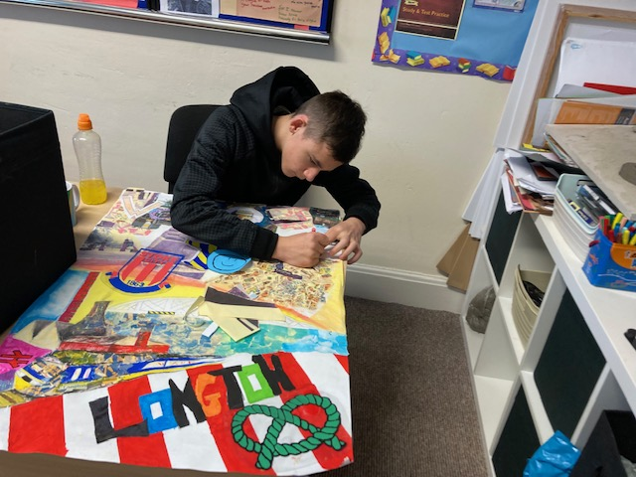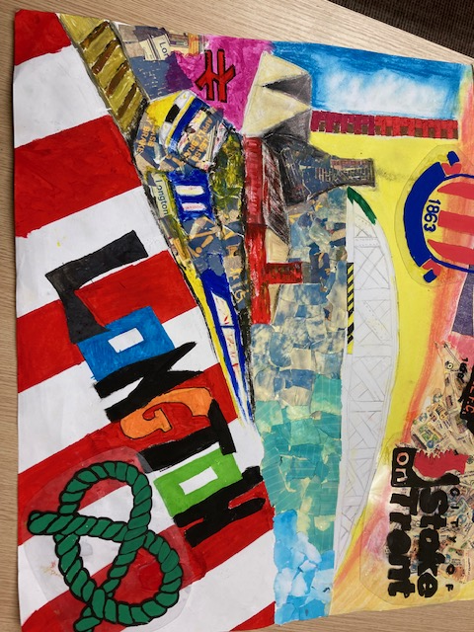
Community Project
All the students have been getting involved with our Longton train station community project. Students have produced a wonderful mixed media poster that will now be scanned and will feature pride of place at the station. The poster is a celebration of local attractions within Longton and Stoke-on-Trent. Well done everyone!!!

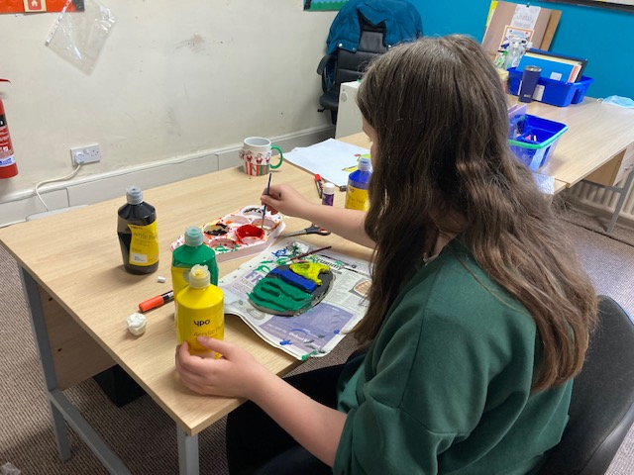
Art:
The students have been continuing with their Identity Project creating their own Stained Glass Windows and 3d Graffiti Names in clay
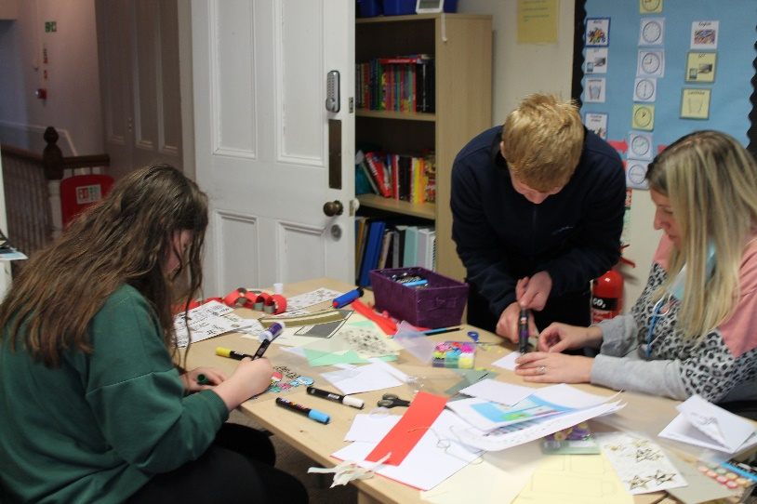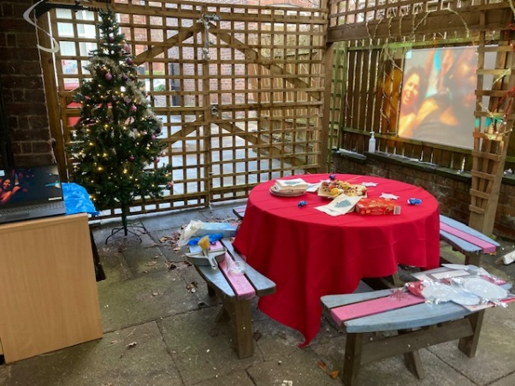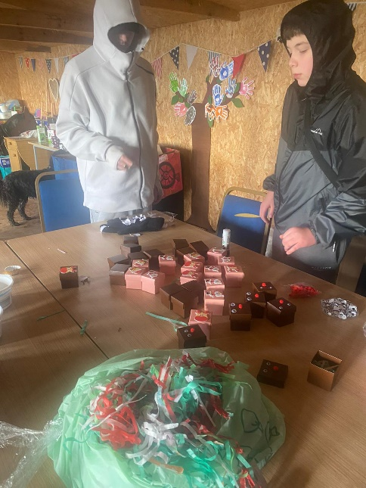
The students made lots of creative gifts to sell to parents at our Christmas Fayre. The Fayre was outside this year but it certainly still had the festive feel with a Christmas tree, food on our dressed table and a video showing parents what our students have been up to this term… oh and let’s not forget the Christmas music!
Thank you to all parents and carers for their contributions to the Christmas Fayre and to Children in Need earlier in the year. We raised: for Children in Need and at the Christmas Fayre, which we will put towards new reading resources.
Personal Wellbeing / PSHE

This term we took part in Anti-Bullying Week on 15 to 19 November 2021 and this year theme was One Kind Word. Kindness is more important today than it has ever been. The students took part in writing a kind word about another student. We then read these out in class.
We have also continued with the topics from last term relationships and friendships.
Christmas Fayre
Physical Education:
Students have been enjoying their PE sessions at the YMCA. Together the students and staff have devised their own version of Dodgeball as they have enjoyed the original game so much. You can see staff and students have also played tennis during these sessions.

During swimming lessons at Trentham Academy’s Swimming Pool some of our students have surpassed our expectations and progressed through the swimming stages well, developing their confidence every step of the way. {See Awards obtained at the end of the Newsletter}

ICT
Students have been working very hard to create their own album cover designs and developing software.
Maths
Many students this term have achieved fantastic results in their Functional Skills assessments, showing they can achieve higher levels as the year progresses. We have changed the way we enter students for exams to enable students to succeed more regularly and build up their qualifications. We already have Assessments planned for February and different intervals through the rest of the year.
End of Term One Awards:
Alfie: Improved attendance and attitude to learning
Alicia Mae: Amazing Animal whisperer at the Farm
Ben: Excellent improvement in Reading Comprehension and confidence across all subjects
Brandon: Fantastic engagement in school life, utilizing all his skills – practical and academic.
David: Outstanding results in English and Maths one to one Assessments
Ellie-Mae: Positive engagement with staff from Intuition School
Jade: Using her nurturing skills to help others, helping everyone to feel happy and always trying her hardest.
Mia: 100% success in trying her hardest in all subject areas.
RubyAnn: Positive engagement with staff from Intuition School
Sienna: A great start to her time with us at Intuition School socializing and engaging with students and staff.
Summer: Well done! You are progressing well, improving your attendance and attitude to School.
Tylah: Improved attitude to all areas of school. Astounding progress through Functional Skills Assessments.
Will: Attending well, working very hard and helping to create a fun atmosphere at school.

Important Dates:
Term ends for Christmas: 16th December 2021
Staff Training Day: 4th January 2022
Term starts for students: 5th January 2022

support@diamond-families.
Swimming Awards:
David: Most improved style and stamina – showing great swimming potential
Jade: Most graceful. Born to be a dolphin!
Mia: Most developed skills. Showing great tenacity.
Kai: Most developed confidence in the water. Courageousness.
In January we will be welcoming three new members of staff: Amy will be teaching Maths and English. Nicola will be teaching Science and Sam will be supporting all learning across all subjects.

Message from Lynn: I would like to take this opportunity to wish every student every success in their future journey at school and beyond. I would like to say thank you to all the students for all their commitment, good humour, friendliness and for making it a genuine pleasure to teach them.
From January Lynn will no longer be teaching at Intuition School as she will be moving on to work elsewhere. We thank her for her contribution and commitment to the school over the past two years and wish her happiness and enjoyment in her new role.

Stay safe and well during the Christmas Festivities and we look forward to seeing you all in January 2022. Quick reminder: Our school days begin at 09:30 and end at 15:00.

Childhood education is a precious time that should be fun and nurturing. It is our mission to empower and inspire learners to enjoy education and seek their own true potential” www.intuitionschool.co.uk 01782315758

“

 | Website: |  |  |  | Contact: |  |  |  | Email:

